DOCUMENT ANALYSIS

Remember, when analyzing documents be sure to:

1. Check the date it was made and the source

a. Is it from the time period of study/a first hand account (Primary or secondary?)

b. Who is the source? Are they biased?

2. What type of document is it? - Letter, photograph, essay, painting, etc.

3. Description of the document

a. What does the document show?

b. What purpose does the document serve?

c. Is there anything interesting about this document or something unusual?

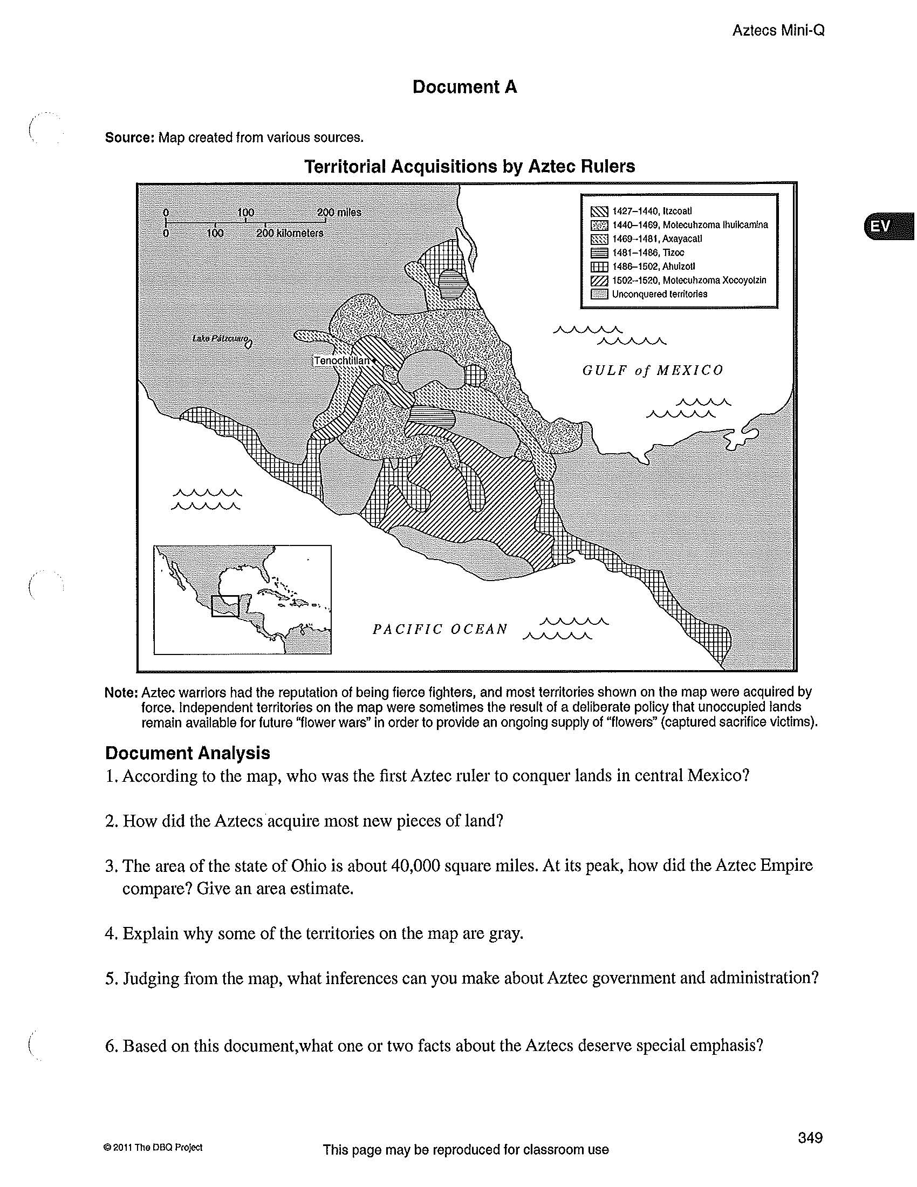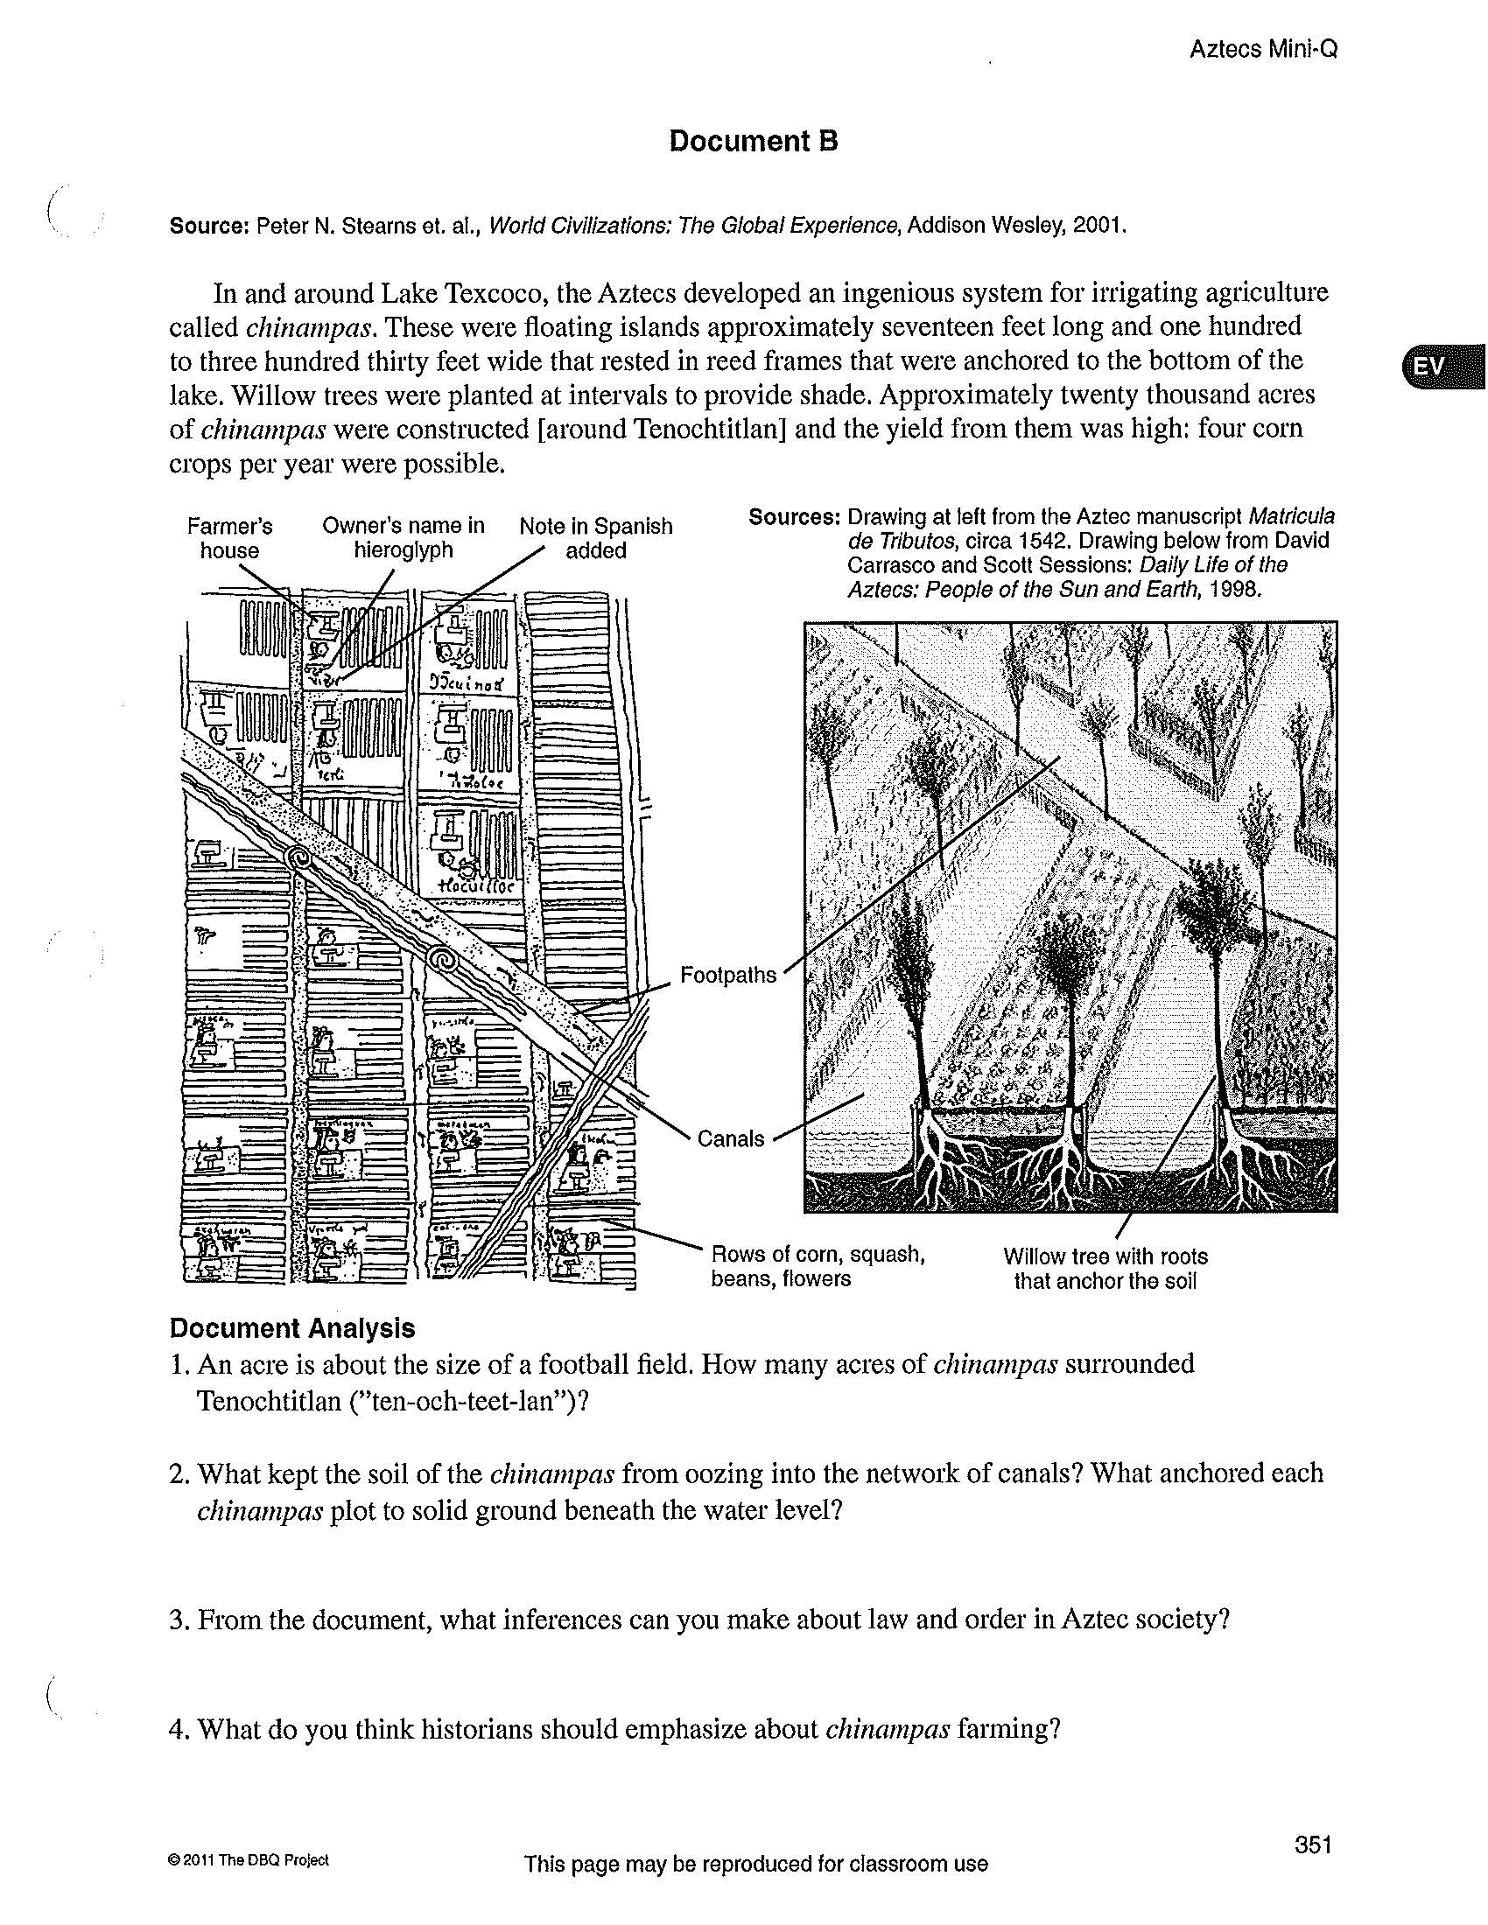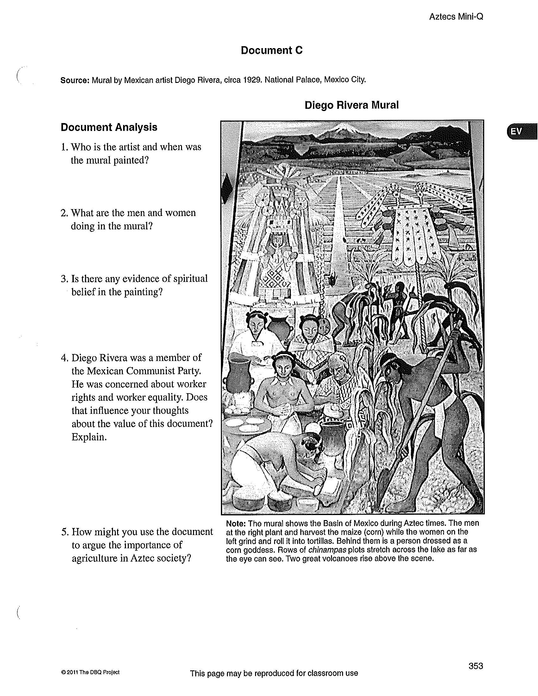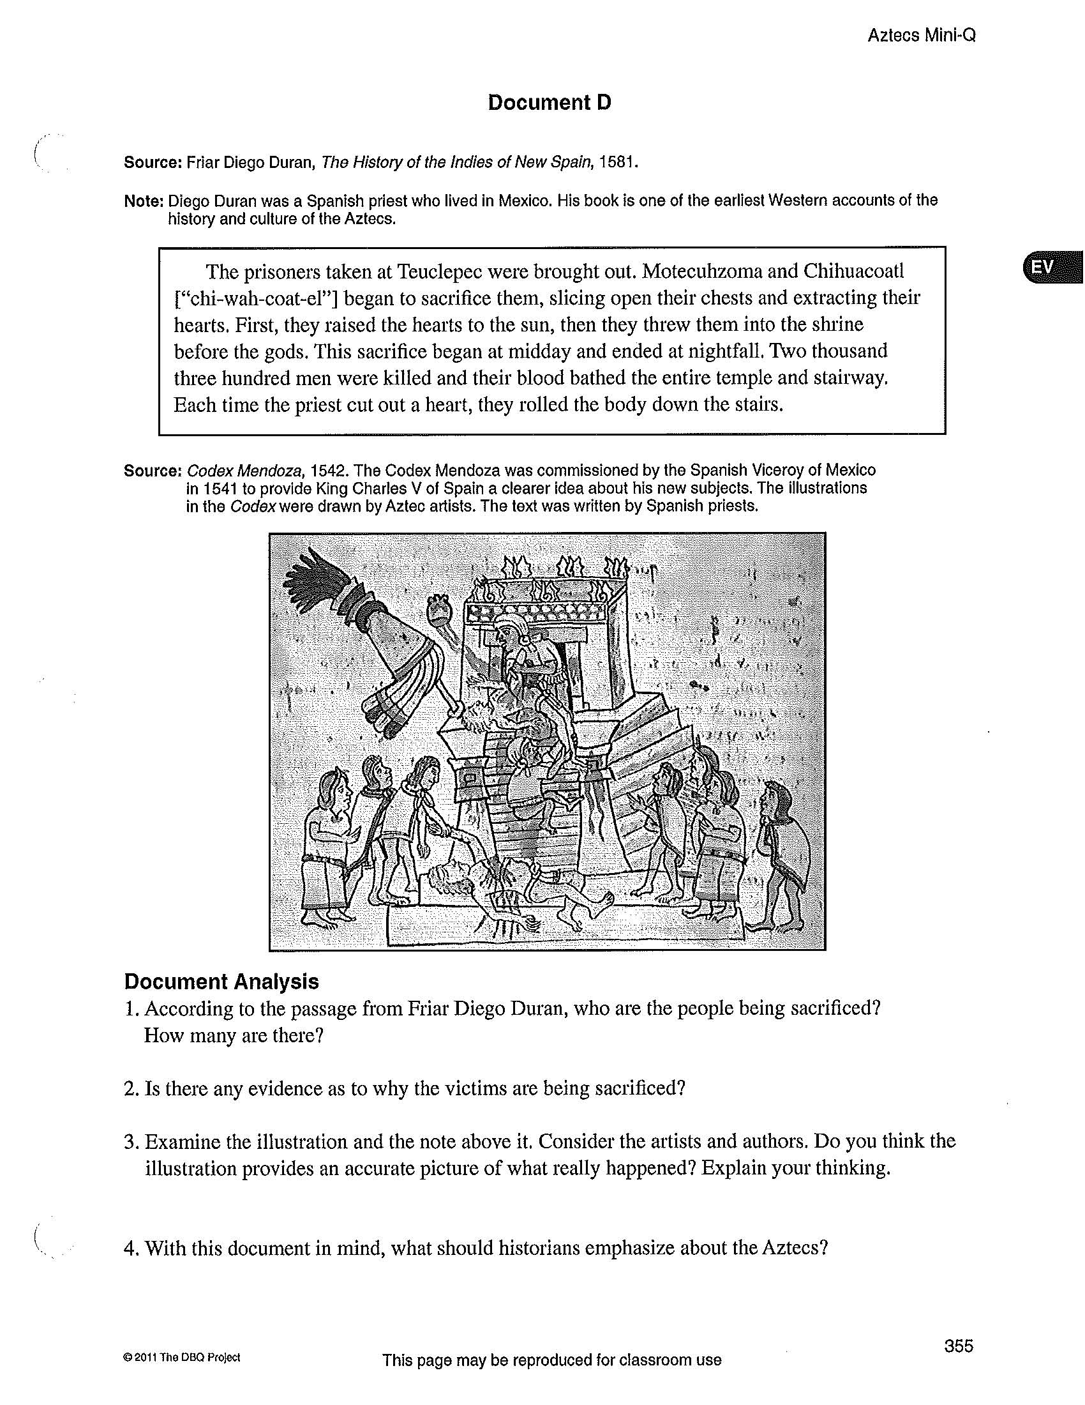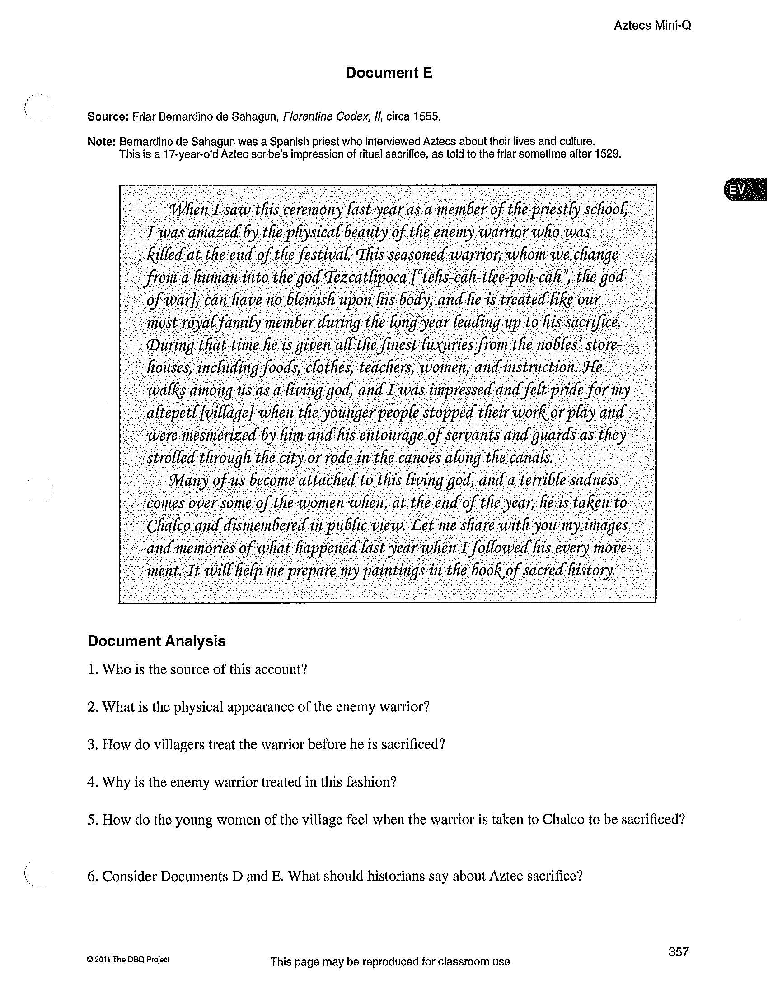
Directions: Using the primary and secondary sources in addition to your own outside knowledge about the Aztecs, respond to the question: “Should historians emphasize agriculture or human sacrifice?” To adequately answer this question, your paper should be around 1-2 pages.

Be sure to use textual evidence from the documents when you write your paper and to cite them specifically/explicitly in your writing! You paper should be typed (and printed out), or neatly handwritten.

In addition to the content, make sure that your paper:

1. DMS Heading

2. Is double-spaced

3. Is Times New Roman

4. Is 12-point font

5. Has 1 inch margins

 | 5 | 4 | 3 | 2 | 1
Thesis  Addresses the prompt and maps out the argument to be made. | Contains a clearly stated thesis that identifies the major reasons used to answer the question. | Contains a general stated thesis that identifies/maps out the major reasons used to answer the question. | Contains a thesis that begins to identify the major reasons used to answer the question. | Contains a thesis that only repeats or rephrases the question | Contains no thesis
Use of Documents: Effectively uses documents to support arguments | Skillfully uses all documents/artifacts and:  - Contains no significant factual errors or misrepresentation of documents.  - Recognizes point of view where applicable.  - Draws inferences and conclusion | Skillfully uses most of the documents/artifacts and:  - Contains a few factual errors or misrepresentations of documents  - Recognizes point of view where applicable.  - Formulates generally accurate conclusions | Uses some of the documents/artifacts and:  - Contains little supplementary information  - Attempts to formulate some conclusions: may contain some factual errors.  - Does not recognize point of view | Uses little information from the documents and:  - Merely quotes or briefly cites documents, or misunderstands documents.  - Draws vague conclusions  - Does not recognize point of view | No use of documents  in essay.
Analysis:  Makes plausible inferences and a rational argument | Incorporates accurate and relevant background knowledge. Presents analysis which reflects understanding of complex issues. | Incorporates accurate and relevant background knowledge. Presents analysis which reflects some understanding/analysis of complex issues. | Attempts rational argument and attempts to connect outside knowledge and/or evidence from documents to the thesis. | Uses minimal information from documents or copies from documents and uses minimal outside information. Analysis, although attempted is not accurate. | Uses unclear or inaccurate information for documents. Includes no outside information .Fails to provide analysis.
Organization and Clarity:  A coherent essay with thesis, topic sentence, analysis, and conclusion | Writes a well developed essay consistently demonstrating clear and logical organization including a strong introductory paragraph that includes a clear thesis and a conclusion that effectively summarizes the argument. | Introductory paragraph includes a clear thesis. Body paragraphs contain topic sentences and substantial supporting evidence. Fluid writing and organization move the argument forward. Student provides basic conclusion. | Unevenly developed with a general plan of organization. Introductory paragraph contains a weak thesis or thesis is misplaced. Some body paragraphs lack cohesion. Describes documents more often than draws conclusion. | Essay is poorly organized. Vague or missing introduction and/ or a conclusion. | Organization is not evident. Does not include an introduction or conclusion
Total Score ___________ and Comments:

